Mehmet Izol

Professor Duisheev

COMP – 5331 – Advanced Cloud Computing

Assignment 3 – HTML App on AWS, S3 Bucket

3/27/2023

HTML App on AWA, S3 Bucket

Screenshot of the AWS Page:

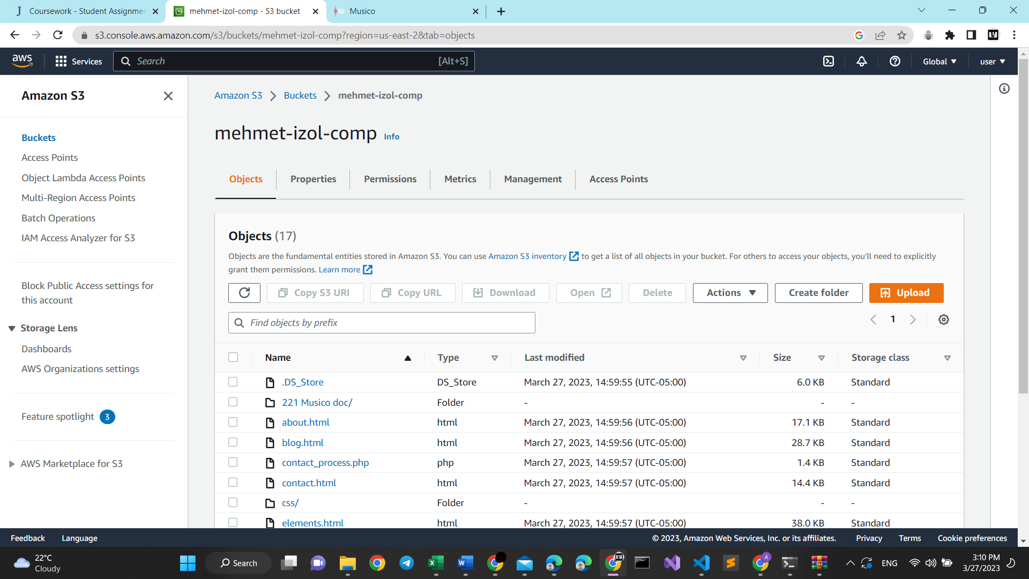

Screenshot of the HTML webpage:

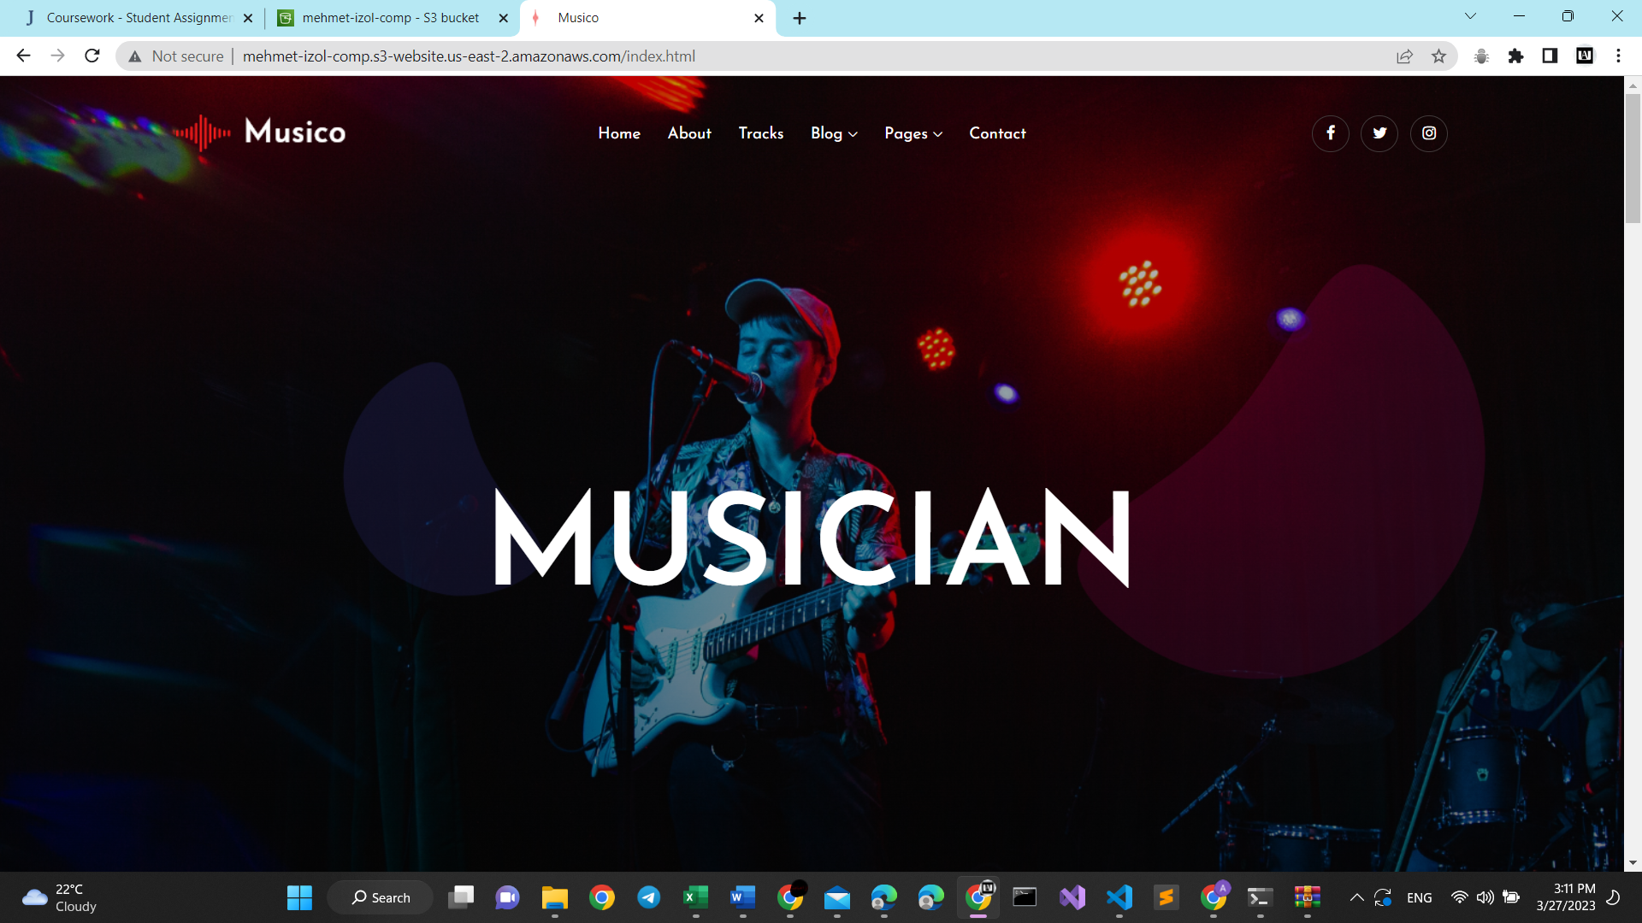

Link to the HTML website:

http://mehmet-izol-comp.s3-website.us-east-2.amazonaws.com/index.html